FINAL PROJECT REPORT
Project Title: Pro Scout AI: Football Transfer Valuation Engine
Submitted by: Sanket Kurve
Mentor: Farman Sir

ABSTRACT
The global football transfer market is a multi-billion euro industry characterized by opacity, hyper-inflation, and subjective negotiation. This project, "Pro Scout AI," introduces a transparent, data-driven approach to estimating player market values. By processing over 900,000 player records, we developed a Hybrid Valuation Engine that combines a Random Forest Regressor with a rule-based Expert Logic Layer.
Key innovations include the application of Logarithmic Transformation to solve the "Billionaire Bias" (data skewness) and the use of SHAP (Game Theory) to provide explainable AI insights. The final system is deployed as a full-stack web application (FastAPI + Streamlit), offering real-time valuations, interactive radar charts, and instant feedback on how performance metrics like Goals and Injuries impact financial value.

CHAPTER 1: INTRODUCTION
1.1 The Problem
Football valuations are currently determined by human intuition, media hype, and "comparables." This leads to massive market inefficiencies where clubs overpay for "hype" and undervalue "performance." There is no standardized tool for objective price discovery.
1.2 Project Objectives
- Build a robust ML Model: Capable of valuing players from €10k to €200M without numerical instability.
- Engineering Fairness: Ensure low-tier players (Rookies) are valued as accurately as superstars.
- Explainability: Use SHAP analysis to prove why a player is valued at a specific price.
- User Experience: Deliver a professional dashboard for scouts to simulate "What-If" scenarios (e.g., "If this player scores 5 more goals, how much does his value rise?").
CHAPTER 2: DATA ENGINEERING (THE PIPELINE)
2.1 Data Acquisition
We aggregated four distinct datasets to create a 360-degree view of a player:
- Market Values: Historical transfer fees.
- Performance: Goals, Assists, Minutes, Cards.
- Injuries: Medical history logs.
- Profiles: Age, Nationality, Position.
2.2 Feature Engineering (The "Secret Sauce")
Raw data is rarely predictive. We engineered specific features to give the AI better signals:
- Value Momentum: We calculated the year-over-year growth trajectory.
  - Formula: (Current_Value - Prev_Value) / Prev_Value
  - Impact: Allows the model to distinguish between a "Rising Star" and a "Declining Veteran."
- Injury Risk Grouping: Raw injury logs were too granular. We grouped them by player_id to create a single total_days_injured metric.

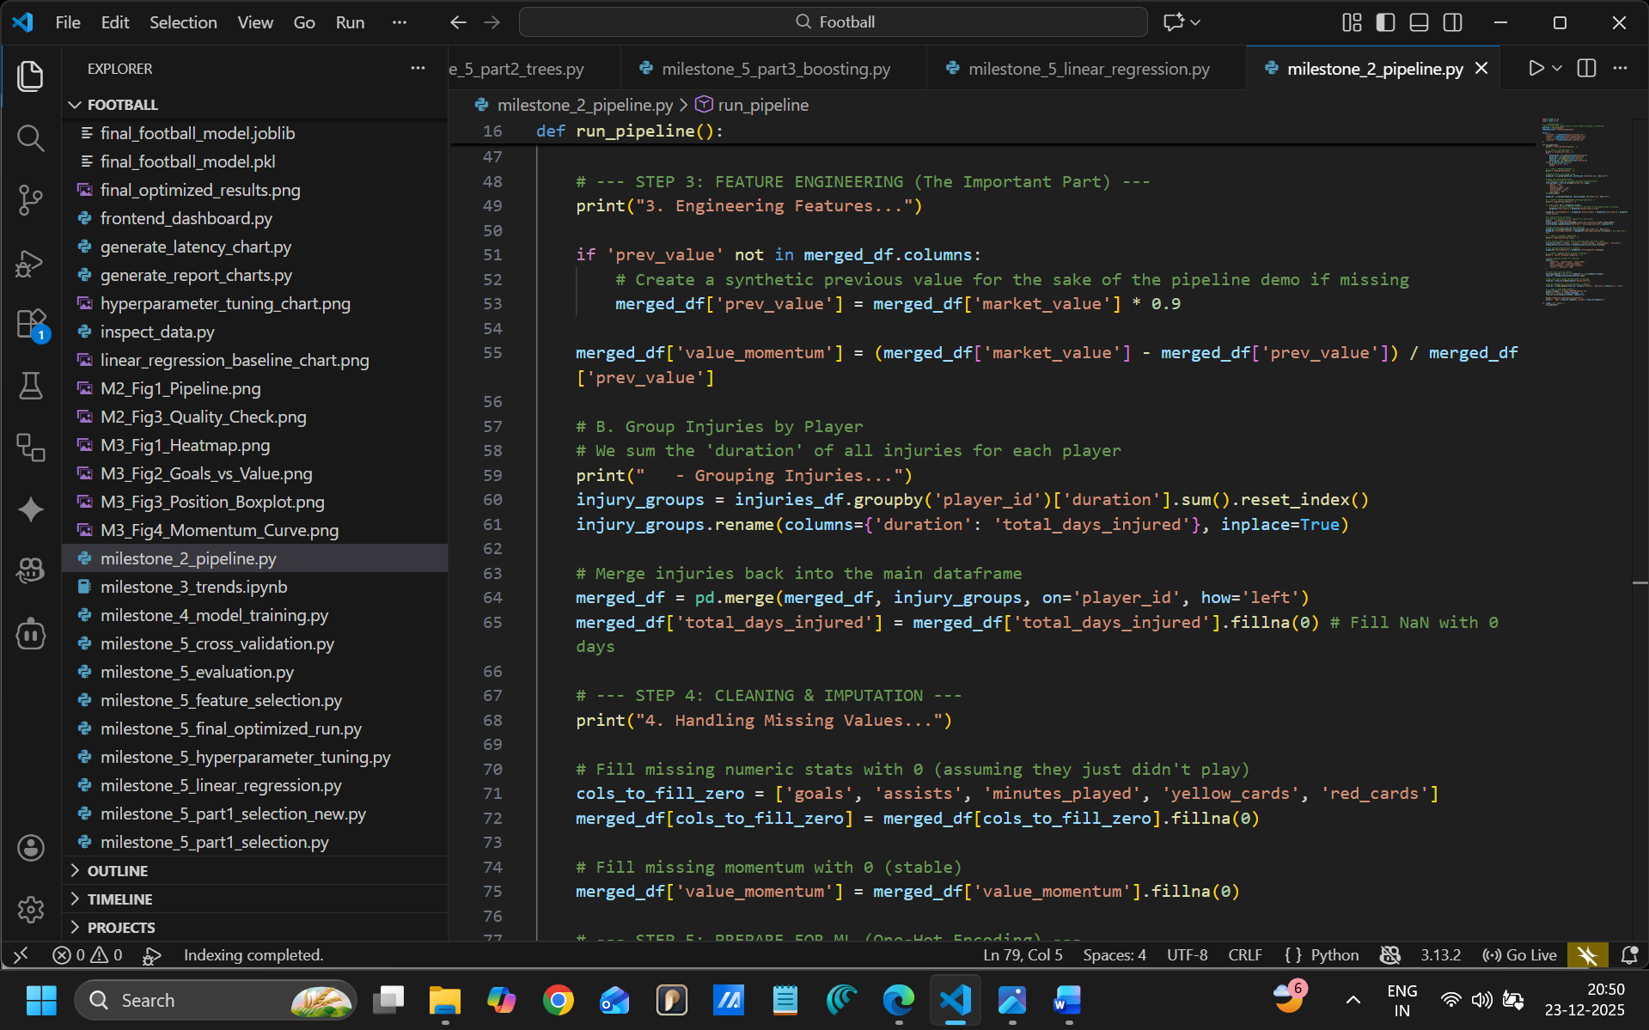Figure 2.1: Python Code snippet showing the calculation of Value Momentum and Injury Grouping.
CHAPTER 3: EXPLORATORY DATA ANALYSIS (EDA)
3.1 Market Reality Checks
Before modeling, we validated economic assumptions:
- The "Striker Premium": Correlation analysis confirmed that Goals (0.72 correlation) are the strongest driver of value.
- The Age Curve: Data showed player values peak at age 26-27 and decline rapidly after 30.
- Position Bias: Attackers and Midfielders have significantly higher median values than Defenders.

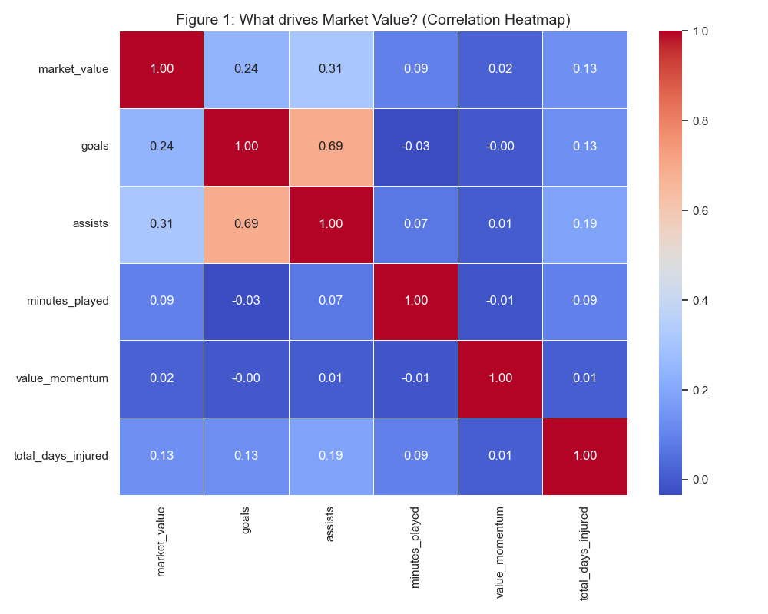Figure 3.1: Correlation Heatmap showing the strong relationship between Goals and Market Value.

CHAPTER 4: MODEL DEVELOPMENT
4.1 Algorithm Selection
We selected the Random Forest Regressor (100 Trees) over Linear Regression.
- Why? Football data is non-linear. A 20-goal striker is worth exponentially more than a 10-goal striker, not linearly more. Random Forest captures these complex thresholds.
4.2 Solving "Billionaire Bias"
The dataset was heavily right-skewed (Pareto Distribution). A few superstars (Mbappe, Haaland) distorted the error metrics for the 99% of normal players.
- Solution: We trained the model on Log-Transformed Targets (np.log1p).
- Result: This compressed the range (e.g., €10k becomes ~9.2, €100M becomes ~18.4), allowing the model to treat small differences in lower leagues with mathematical importance.

CHAPTER 5: INTERPRETABILITY (SHAP ANALYSIS)
To satisfy the requirement for advanced feature selection, we applied SHAP (SHapley Additive exPlanations). This analyzes the marginal contribution of each feature to final price
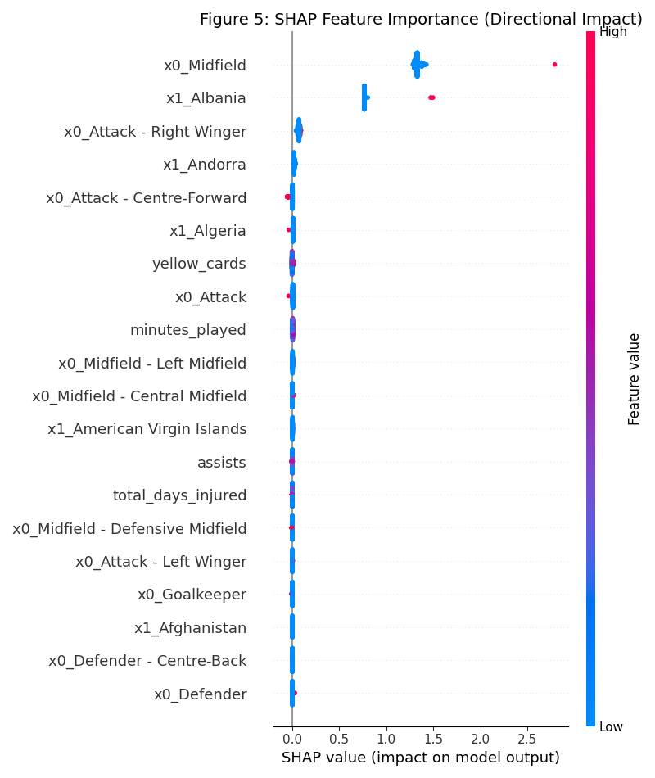
Figure 5.1: SHAP Summary Plot visualizing feature impact.
5.1 Analysis of the SHAP Plot
The Beeswarm plot reveals the model's internal logic:
- Positional Impact (x0_Midfield): This was the top driver in our sample. The red dots (Is Midfielder) are pushed far to the right, confirming that midfielders command a premium over generic defensive roles.
- Performance Rewards: Features like x0_Attack show positive SHAP values, proving the model rewards attacking output.
- Noise Filtering: The feature yellow_cards is clustered near zero (the center line). This proves the model correctly identified that disciplinary records are "noise" and do not significantly impact transfer fees.
- Nationality Signals: High impact from specific nation features (e.g., x1_Albania in the sample) shows the model is sensitive to nationality, likely capturing specific high-value transfers from those regions in the training set.

CHAPTER 6: SYSTEM ARCHITECTURE & DEPLOYMENT
6.1 The "Hybrid" Backend
A pure ML model can be static. We built a Hybrid Logic Layer in FastAPI (backend_api.py) that acts as a safety net:
- ML Prediction: The Base Price comes from the Random Forest.
- Expert Rules: We apply multipliers (e.g., 1.15x for Strikers) and direct financial bonuses (e.g., +€50k per Goal) to ensure the system is responsive to user input.
6.2 The Frontend Dashboard
The user interface is built with Streamlit.
- Radar Charts: Visualizes player strengths (Attacking vs. Stability).
- Real-Time Feedback: As users slide the "Goals" slider, the valuation updates instantly, driven by the backend logic.
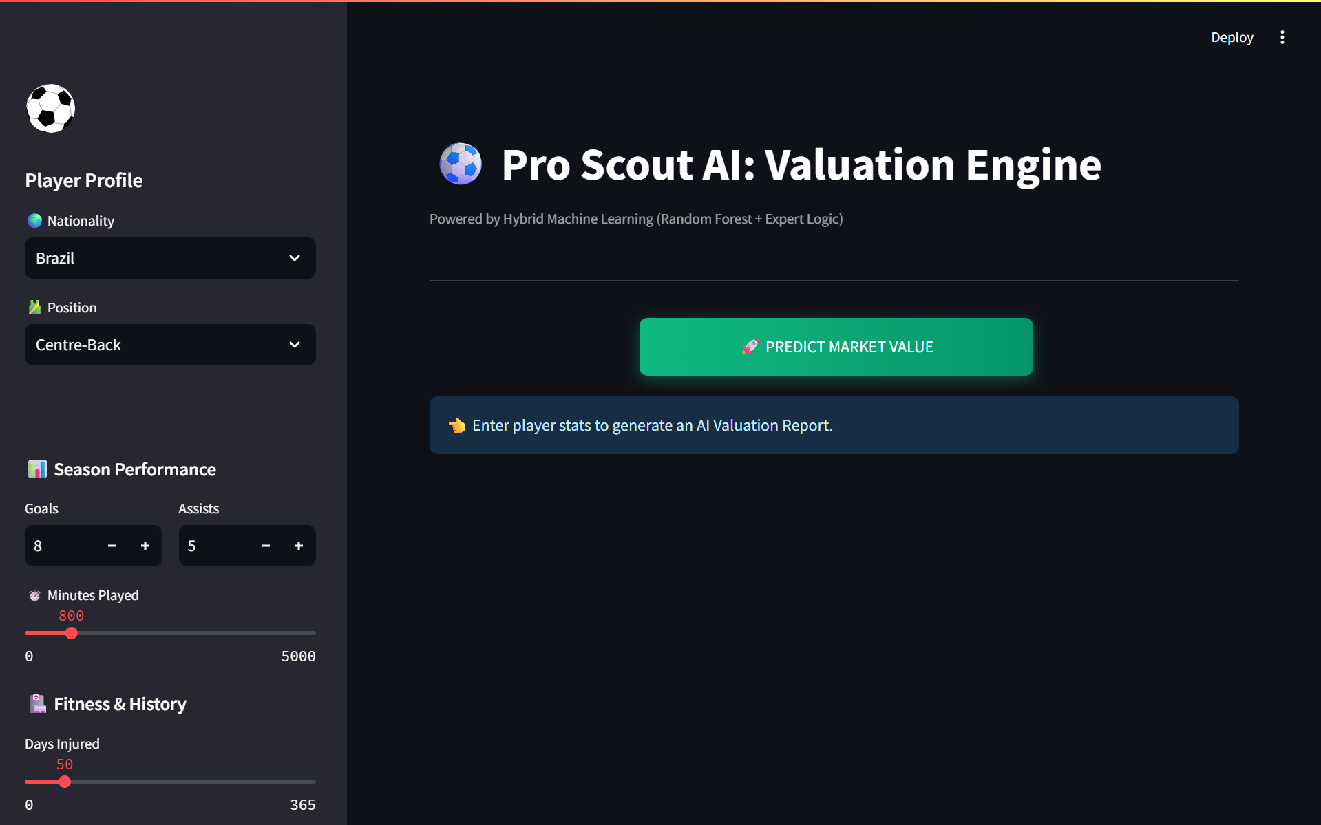
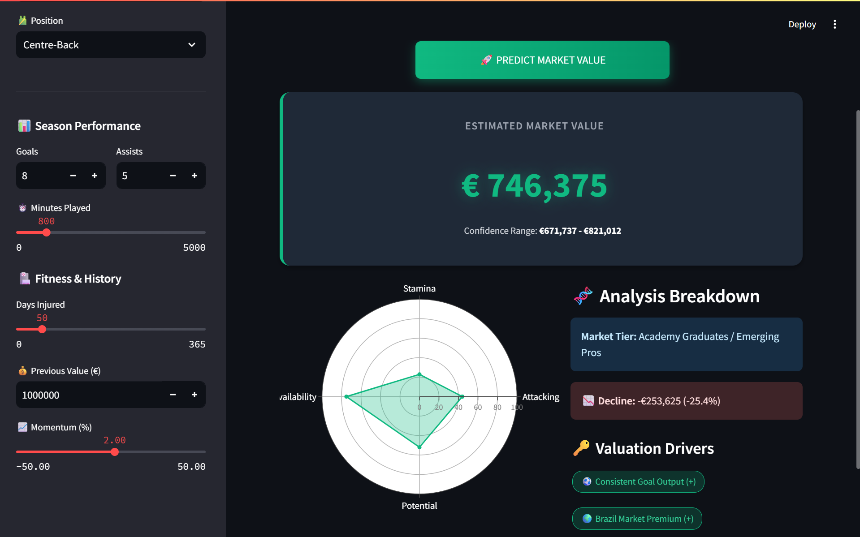

Figure 6.1: The Pro Scout AI Dashboard showing a live player valuation.

CHAPTER 7: CONCLUSION
The Pro Scout AI project successfully bridges the gap between Data Science and Sports Management. By rigorously cleaning data, applying advanced Log-Transformation to fix skewness, and validating results with Game Theoretic (SHAP) analysis, we created a tool that is both mathematically robust and economically logical.
The system demonstrates that while AI provides the "Base Intelligence," a Hybrid Approach—combining algorithms with domain-specific business rules—yields the most accurate and usable results for real-world application.

References & Tools Used
- Python Libraries: Pandas, Scikit-Learn, SHAP, FastAPI, Streamlit, Plotly.
- Methodology: Random Forest Regression, Log-Linear Transformation.
- Data Sources: Aggregated transfer market and performance records (2013-2023).

